Lancashire Skills & Employment Hub Appendix A
Purpose
To support the Lancashire Skills & Employment Board to discharge its duties and in doing so facilitate/enable a better balanced, skilled and inclusive labour market which underpins and contributes to economic well-being and growth across the County. The Skills & Employment Hub is a strategic unit not a delivery organisation.
Key Objectives
- To maintain a robust evidence base for Lancashire and a Skills and Employment Strategic Framework which will drive a balanced, skilled and inclusive labour market.
- To consult and gain stakeholder ownership of the Skills and Employment Framework and allied actions, and facilitate and monitor implementation.
- To use the Skills and Employment Framework and related intelligence to influence and prioritise the use of relevant mainstream and discretionary funding, policy and reviews. For example:
  - The Lancashire European Structural Investment Fund (ESIF) strategy and allocation of funding, in particular European Social Funds (ESF).
  - Driving the development of the skills and employment offer, maximising the impact of policy reforms (for example, technical education).
  - Prioritisation of skills capital allocations via Growth Deal.
  - Asks of Government in the context of the Industrial Strategy, Northern Powerhouse Partnership and the devolution agenda.
- To be a hub of intelligence in regard to relevant policy and labour market intelligence (LMI) for local stakeholders and to influence and position Lancashire in the Local Enterprise Partnership (LEP) network and nationally.
- To be a catalyst for improving supply side capacity and responsiveness, instigating innovation and the development of new products and services (delivered by providers).
- To facilitate a coherent 'umbrella' of marketing and communications activities (which add value to individual provider activity and which align with the local Growth Hub – 'Boost') and drive the engagement of employers and learners.
Focus for 2016/17
- Evidence based updated and Skills and Employment Framework refreshed, following the refresh of the Strategic Economic Plan, including the development of a Technical Education vision and strategy.
- Oversight of contracted ESF activity, including implementation and embedding of the Skills Escalator, to maximise impact on learners and businesses. Prioritisation of remaining ESF funding (subject to guidance from DWP).
- Oversight of contracted Growth Deal skills capital and delivery of outputs and outcomes, working with the Growth Deal Programme Team.
- Implementation of the Lancashire Apprenticeship Plan.
- Development and implementation of post-ABR non-structural recommendations and the collaborative action plan.
- Oversight of the Lancashire Enterprise Adviser Network and the inspiration agenda in schools and colleges, aligning activity with the imminent Careers Strategy, and driving the aspiration theme in the Blackpool Opportunity Area.
- Evidence of marketing and communications activities which have engaged employers.

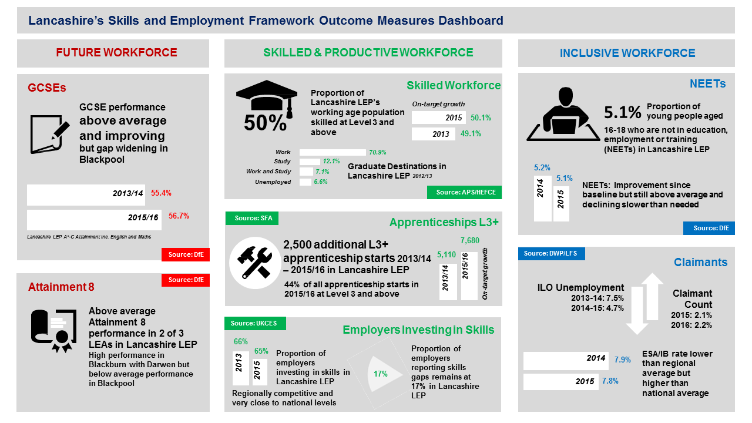
Dashboard of outcome measures (January 2017)

Stakeholders include employers, providers (public, private and third sector), representative bodies, Local Authorities and other relevant interested parties.

